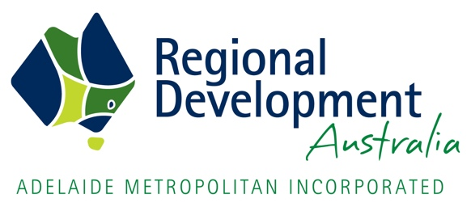

Strategic Investment Projects Accelerator Regional South Australia (Fund)
Application Form

Please read the Guidelines available for this fund prior to completing this form:
Project Details
Project Title
Project Summary
(max 500 words)
Project Location (the proposed investment must be in South Australia and ideally benefit more than one region) | You may select multiple box’s:  Barossa, Gawler, Light & Adelaide Plains  Eyre Peninsula  Far North  RDA Adelaide Hills, Fleurieu and Kangaroo Island  Limestone Coast  Murraylands & Riverland  Yorke and Mid North
Requested Funding  (GST inclusive) | $  NOTE: Funding of up to $50,000 (gst inclusive) may be awarded. Please note that it is a requirement that any amount granted will be matched dollar for dollar by the applicant, and must be an actual cash contribution

Project Applicant
Lead Organisation Name:
ABN:
Project Contact Name:
Phone:
Email:

Project Partners
Partner Organisation 1
Name of Contact
Phone
Email
Partner contribution (max 100 words)

Partner Organisation 2
Name of Contact
Phone
Email
Partner contribution (max 100 words)

NOTE: Please add as many tables as you require to list all the organisations which are partnering with the proponent to deliver this project.

Project Impact & Community Development
Considering the assessment criteria outlined in the Guidelines, provide below or attach as much supporting evidence as you can, including:
Total Project Investment
Describe the anticipated capital investment and other that will be required to deliver this project
Why is this Project important for the region/s?
(economically, community, strategically)
Does the region/s support this project?
Provide evidence if possible
What is the likelihood of this Project attracting the funding it needs? Where do you think this funding will come from?
Can you deliver the Project?
Demonstrate your experience and capacity to deliver on any specific requirements needed for this project as well as your knowledge of the region/s
Why does this Project need these Funds?
This Fund is intended to enable projects that really need support, it is not intended to reduce costs for projects that would occur regardless of support

Budget
Income
Funding Sought from this Fund | $
Total Applicant / Partners Cash Contribution | $
Total Applicant / Partners In-kind Contribution | $
Funding from other sources (if any) | $
NOTE: Salaries and administration costs directly attributable to the development of the feasibility study / business case can be included in the in-kind contributions.
Expenditure
Consultants Fees | $
Other specialist Service Fees | $
NOTES:
- Please provide quotes as evidence of the costs associated with delivery of the feasibility study / business case. Local procurement is strongly preferred however we understand that some specialist services may need to be sourced from outside South Australia, if this is the case please provide justification.
- The Fund is intended to pay for consultancy fees and costs associated with external professional services to develop and provide the feasibility study / business case. The Fund will not cover the applicant or project partners general operational costs.

Endorsement of Applicant
Name
Signature
Date

Submit your completed application and supporting documentation ceo@rdaadelaide.com.au by 5pm Friday 30th April 2021.

CONTACT DETAILS
RDA Adelaide Metro
CEO: Karen Raffen
Email: ceo@rdaadelaide.com.au
Phone: 0412 300 119

